Spring 2022 Active Planet – Great Scott!!
In Class Two our topic has focused on Active Planet and our first half term we learnt all about Antarctica and many expeditions which took place trying to reach the South Pole. These included expeditions from Robert Falcon Scott and Ernest Shackleton.
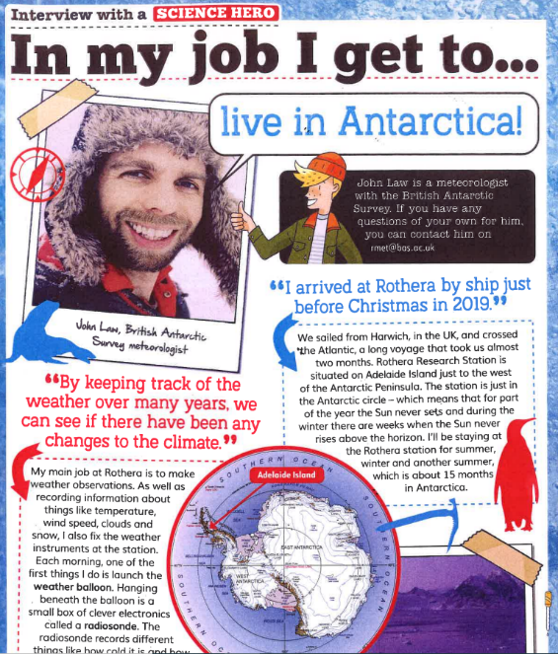
At the end of last half term, we were provided with an amazing once in a lifetime opportunity. We were able to contact the British Antarctic Survey Team, actually in Antarctica! We had the chance to talk to them via email to ask them questions and find out more about their scientific jobs and life in such a cold climate.
We were so lucky with the communications which we had between our class and the real scientists and we exchanged many emails.
Not only have they have sent us a postcard (it could take some time to arrive) but the British Team based in Cambridge sent us a class pack with maps, bookmarks and information leaflets.
Class Two then wrote a letter each to the Antarctic Team and we emailed them across to them. They were able to ask more questions to further their learning.
In response to our letters, the scientists wrote us a detailed letter back including photos.
What a wonderful and real opportunity which really has brought our learning to life!
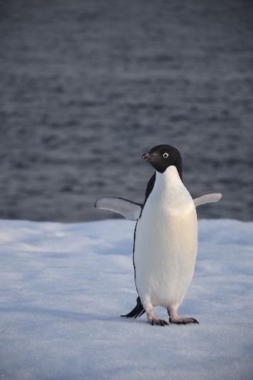
We hope you enjoy reading their final response letter as much as we have.

Best wishes,
Mrs Laurence and Class Two

