A day in the life of Class 1
On arrival (between 9-9.15), we welcome the children in and help them to find their named peg and basket to store their personal belongings. We encourage the children to self- register by completing a simple ‘You choose’ exercise. For example, choosing between two different nursery rhymes that can then be sang at the end of the day. (PSED, CL)
9:00 – 9:30 Children can either choose a book to read with a friend, listen to a story on the interactive board or complete a cosmic yoga exercise whilst the other children arrive. The children are then registered and asked what they would like for lunch. After this, the continuous provision activities for the morning are introduced and explained to the children before splitting into a Reception group and a pre-school group for a phonics session. (PSED, CL, PD)
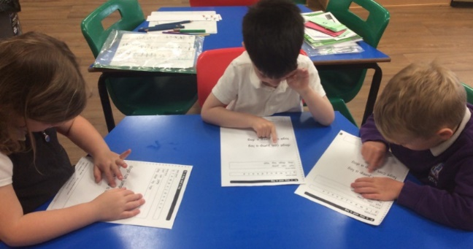
9:30 – 10:15 Miss Marshall/Mrs Kennard lead the Reception group for phonics. The children practice reading a range of decodable and non-decodable words, as well as reading a selected piece of text. In addition, the children practice writing simple sentences and words that contain particular graphemes and spelling patterns. The children work in smaller groups with an adult to complete the writing aspect of the session whilst all other children are able to complete the continuous provision activities in or outside of the classroom. (ALL AREAS OF LEARNING)
Mrs Hutchings leads the pre-school phonics group which involves the children playing lots of different games focusing on making different sounds, listening and rhyming. (CL, L)
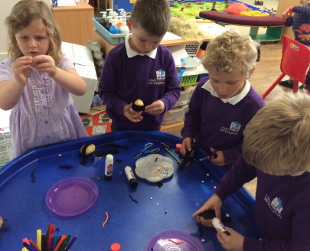
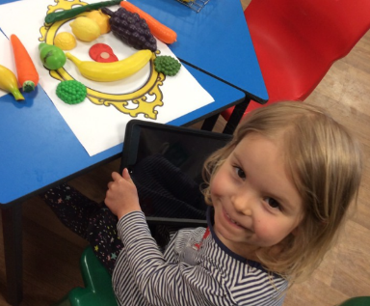
10:15- 11:00 All of the children continue to engage in the independent learning activities both inside and outside as well as having the opportunity to sit and have a morning snack at a time they choose. (ALL AREAS OF LEARNING)
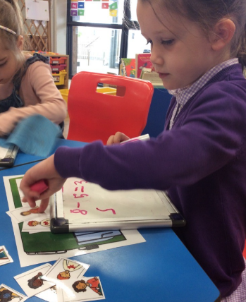
11:00- 11:15 The children come to the carpet for a maths input that generally involves practicing counting, playing some maths games, listening to counting songs and solving some number problems using the interactive whiteboard. (M)
11:15- 11:50 The children work in a small group or one to one with an adult to complete a maths activity based around the daily input they have received. All other children continue with their independent learning. (ALL AREAS OF LEARNING)
11:50 – 12:30 We put on the tidy up song and encourage all children to help tidy up the classroom and outside area. Once the classroom is tidy, we complete our whole class worship. This sometimes involves listening to a story, song or video focusing on a particular Bible story. We also regularly have visitors from the Church lead the collective worship sessions. (CL, UW, PSED)
The children are then read a story or have dancing time, where they dance to 1 or 2 action videos before lunch. The children are sent in small groups to the toilet and wash their hands ready for lunch. (PSED, PD, L, CL)
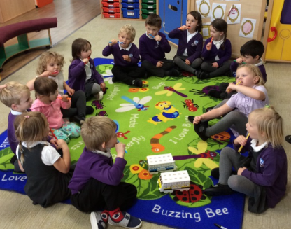
12:30 – 1:30 Lunch is served by our mealtime assistants in the classroom. Children can have a choice of a hot dinner or bringing a packed lunch from home. Good table manners and social interaction are encouraged, and after lunch the children go outside for their playtime.(PD, CL, PSED)
1:30 – 1:40 The children come in from outside, wash their hands and sit on the carpet for tooth-brushing. (PD, PSED, UW)
1:40 – 2:45 We follow an afternoon timetable as follows:
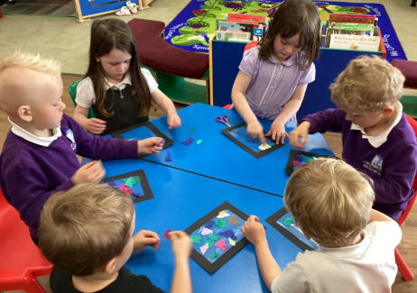
Monday – Topic (UW, CL)
Tuesday – PE in the community centre (PD)
Wednesday – Art/PSHE (PSED, EAD, CL)
Thursday – RE/Music (UW, EAD)
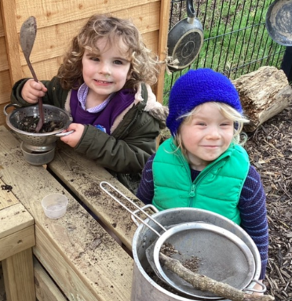
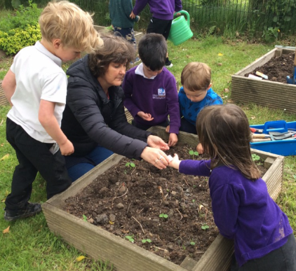
Friday – outdoor learning either in our own outdoor area or in the nearby woodland. (UW, EAD)
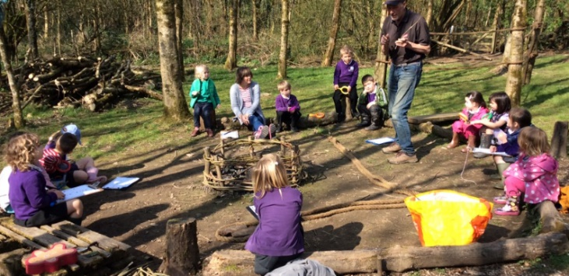

2:45 – 3:15 Tidy up time, story and singing before making sure everyone has their belongings and is ready to go home after a busy day. (PD, EAD, PSED, CL, L)
AREAS OF LEARNING
L – Literacy
CL – Communication and Language
PSED – Personal, Social and Emotional Development
M – Maths
EAD – Expressive Arts and Design
UW – Understanding the World
PD – Physical Development

