Music at home



Yumu is a safe online space where children learn, play and develop their musicianship.

How to log on?
This video shows children and their parents or carers, how to log into the platform, access its resources and complete any assignments set by school.
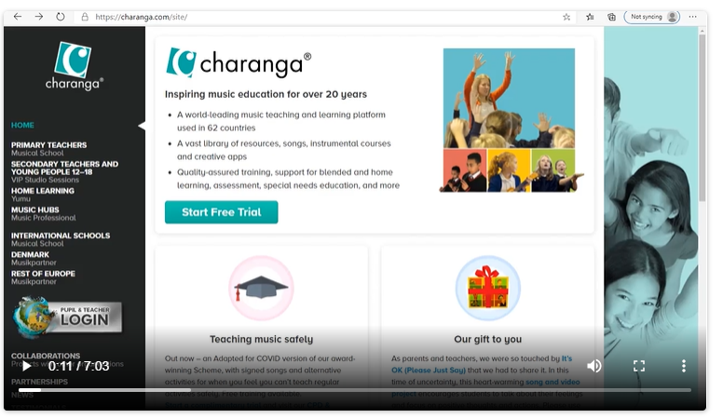

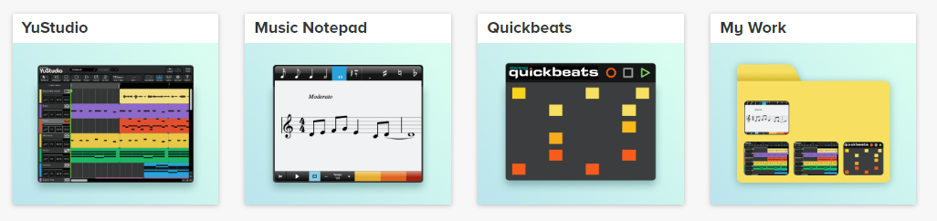
Some of the fun activities you can access online!


