Musician of the Month:2023-2024
 | Musician: | Genre: | Facts: | Famous Pieces:
January |   Léonin | Classical (Early) | 1135 – 1201 (Middle ages)  French  - One of the first identifiable composers in the history of Western music  - He lived and worked in Paris in the Notre Dame Cathedral  - He was the earliest known composer of polyphonic art music as well as of the earliest notation to convey rhythm. | - Ordo Virtutum  - A Feather on the Breath of God  - Heavenly Revelations
February | Haydn  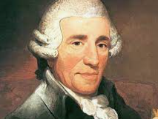 | Classical | 1732 – 1809  Austrian  - He was a friend and mentor to Mozart and even taught Beethoven!  - Haydn composed over 750 works for the orchestra, voice and piano | - String Quartet in C major, Op.76 No.3.  - Overture for an English opera: Largo
March | Einaudi   | Classical  (Contemporary) | 1955 – still alive  Italian  - Einaudi has managed to combine elements of traditional classical music into a new modern classical style.  - He has composed many pieces for films and television shows. He even composed and performed a piece on a real iceberg for Greenpeace calling for Arctic protection. | - Elegy for The Arctic  - Time Lapse  - Lady Labyrinth
April | Vivaldi  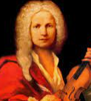 | Classical  (Baroque) | 1678 - 1741  Italian  - His most popular work was written for a group of 4 violin concertos called “The Four Seasons”  - Vivaldi’s dad taught him how to play the violin. | - The Four Seasons  - Gloria  - Magnificat
May | 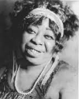  Ma Rainey | Blues | 1886– 1939  American  - Known as “The Mother of Blues”  - One of the earliest recorded blues musicians  - She made over 100 recordings | - Runaway Blues  - Prove it on Me Blues  - Jelly Bean Blues
June | Nina Simone  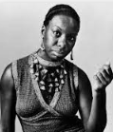 | Jazz | 1933 – 2003  American  - Known for her diverse style and unique voice, Nina Simone is known as one of the most famous and influential singers in American history  - Nina Simone is also known for her tireless activism during the Civil Rights Movement. | - My Baby Just Cares for Me  - I wish I knew how it would feel to be free  - I put a spell on you  - Feeling Good
July | Basement Jaxx   | Dance/Electronic | 1990s – 2000s  British  - Felix Buxton and Simon Ratcliffe are DJ’s, the pair got their name from a regular music night they held in London  - They would use different vocalists in their music  - They have won many awards for their music | - Where’s Your Head At  - Red Alert  - Do your thing
August | Which musicians will you listen to over the summer?
September | 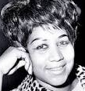  Aretha Franklin | Soul | 1942-2008  American  - Her voice was declared “a natural resource” by America, considered to be one of the greatest soul singers, famous for her dramatic captivating flexible voice. | - Lean on me  - Respect  - I say a little prayer
October |   Kishori Amonkar | Indian Classical Music | 1932 – 2017  Indian  - She is considered to be one of the best Indian classical vocalists  - Kishori was originally trained by her mother and composed ragas | - Avagha Rang Ek Jhala  - Bolava Vithal Pahava Vithal  - Raga Basant Bahar
November | Trinidad Steel Band  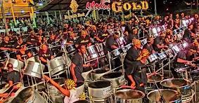 | Calypso/Carnivals | 1940s – present  Trinidad  - The steel band originated on the Caribbean island of Trinidad  - An invention of poor people in Port of Spain who played music during Carnival to represent their neighbourhoods and to compete with rival bands. | - Mongoose  - Tropical Bird  - Una Paloma Blanca
December | 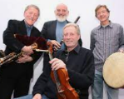  The Chieftains | Irish Folk | 1962 – present  Irish  - Tubridy on flute and concertina, Potts on tin whistle, Fay on fiddle, Fallon on bodhran (a goat-skin drum), and Moloney on tin whistle and uilleann pipes. | - The Foggy Dew  - Cotton-Eyed Joe  - Changing Your Demeanour

