Instrument Lessons
- At High Bickington Academy we now have three peripatetic music teachers who offer private instrument lessons; either one to one or in small groups.

- The teachers come into school once a week during term time and lessons are during the school day.

- Please contact the Miss Trofa or Mrs Goss for the cost of lessons and availability.

- If your child is interested in learning but doesn’t have an instrument, the teacher may have an instrument that they can borrow or hire – please ask.

Instrument: | Instrument: | Teacher: | Day the lessons are taught:
The Voice/Singing | 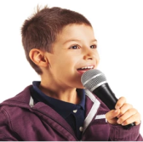 | Stuart Snelling | Monday afternoon
Keyboard/Piano | 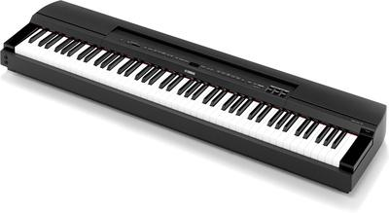 | Alex Rogozinski | Wednesday or Thursday afternoon
Drums | 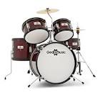 | Dawn Adie | Friday afternoon
Guitar | 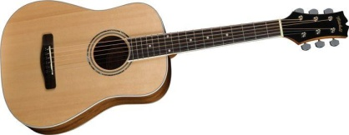 | Alex Rogozinski | Wednesday or Thursday afternoon
Rock Band  Keyboard, electric guitar, drums, voice. Taught in groups.  ALL INSTRUMENTS ARE PROVIDED BY STUART | 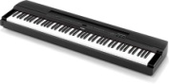  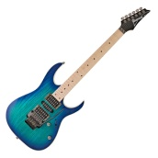 | Stuart Snelling | Monday afternoon

